Egov Environment setup guide
- [Optional] On disk C create a folder “dev” (will serve ) as the root folder for development.
- [Optional] In C:\dev , create two subfolders :
  - Tools (which contains the dev tools)
  - Workspaces (which contains the code developped)

- Install Java (JDK and JRE) C:\dev\tools\java . In order to use glassfish4 , we must have Java Jdk version 1.7
- Add JAVA_HOME into your environment variables (JAVA_HOME= C:\dev\tools\java\Jdk1.7.0_XX , where XX stands for the update number)
- Add the java/javac command into the path
- Install Eclipse
- Install Glassfish 4 into C:\dev\tools\ (just uncompress the glassfish zip file into C:\dev\tools, and you will have C:\dev\tools\glasssfish4)

- Testing glassfish:
  - Open the DOS command line
  - Go into glassfish bin folder (C:\dev\tools\glasssfish4\bin)
  - Execute the following command asadmin start-domain
  - Wait for the message “Command start-domain executed successfully”
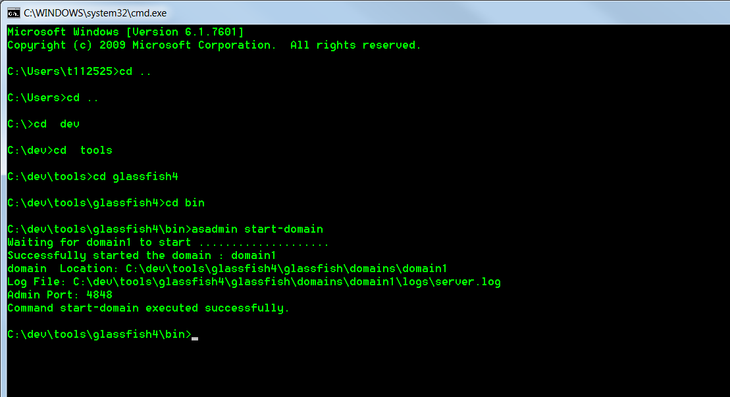
  - Close glassfish with the following command :
asadmin stop-domain

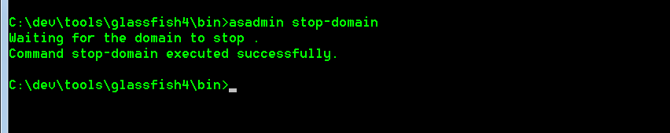

Workspace setup

- Install Eclipse in C:\dev\tools
- Start Eclipse
- On the workspace , write “C:\dev\workspaces\egov”.

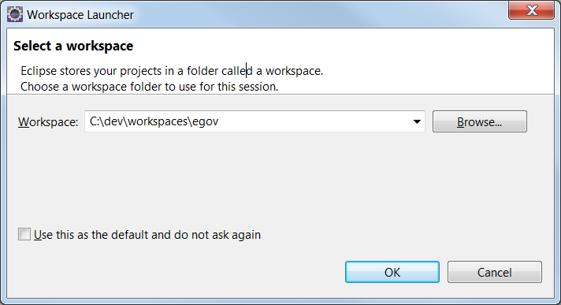

- Choose the the jre for this workspace . Make it the JDK installed in step 3.
Menu window → preferences → java → Installed JREs , click “Add..” button
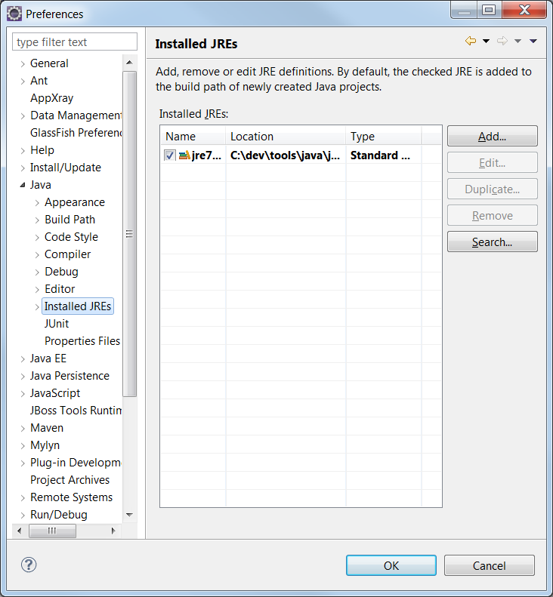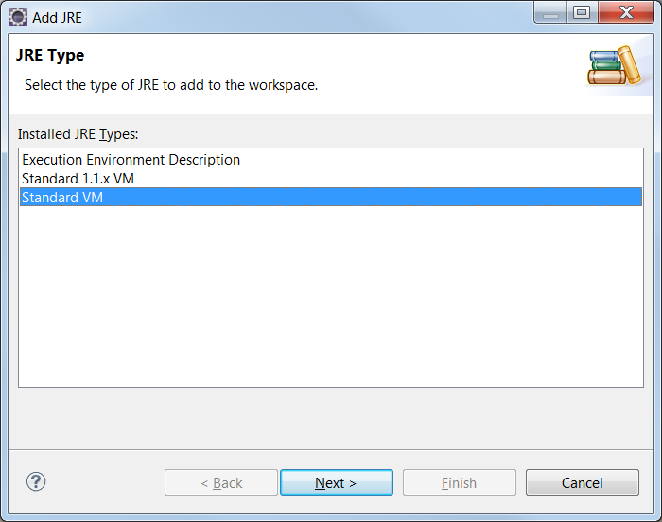
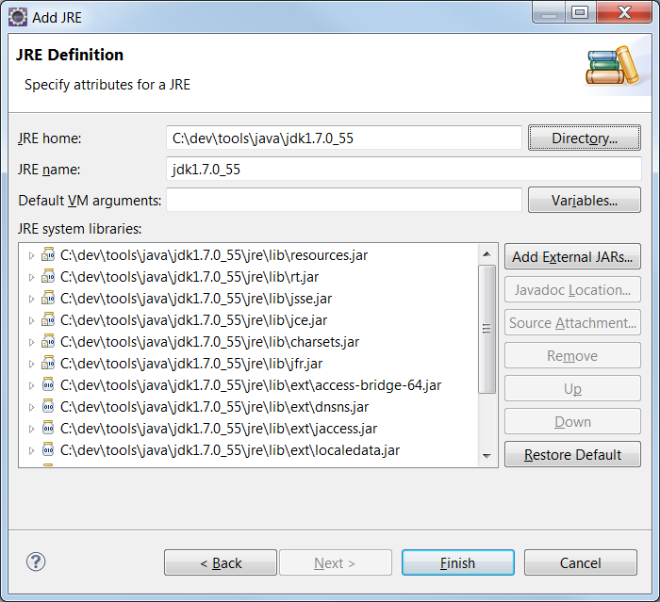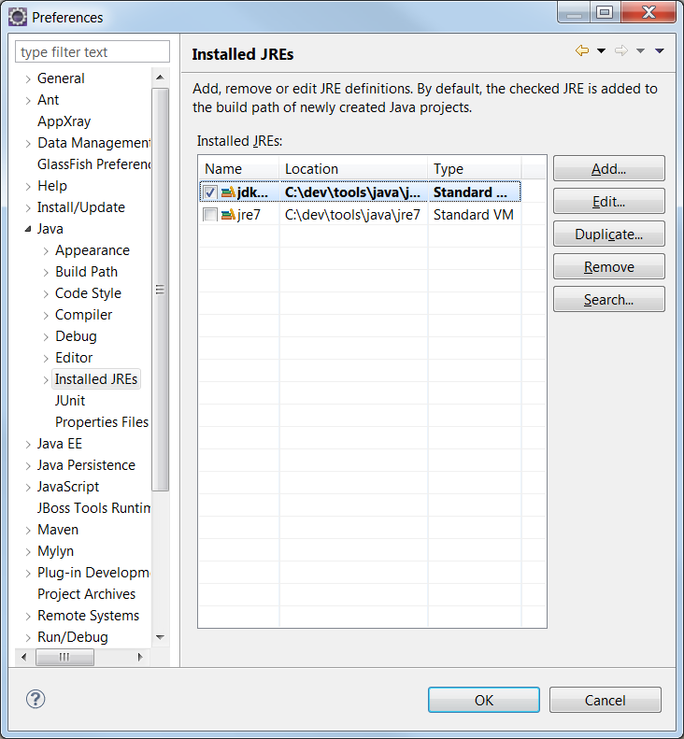

At the end (cfr last screenshot), make sure the default (checked)

- Getting the code from GitHub

  - Change the perspective to “Git repository Explorer” & click on “clone a Git Repository”

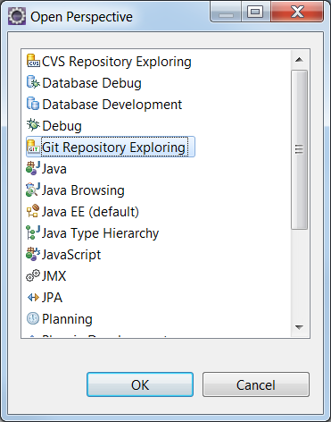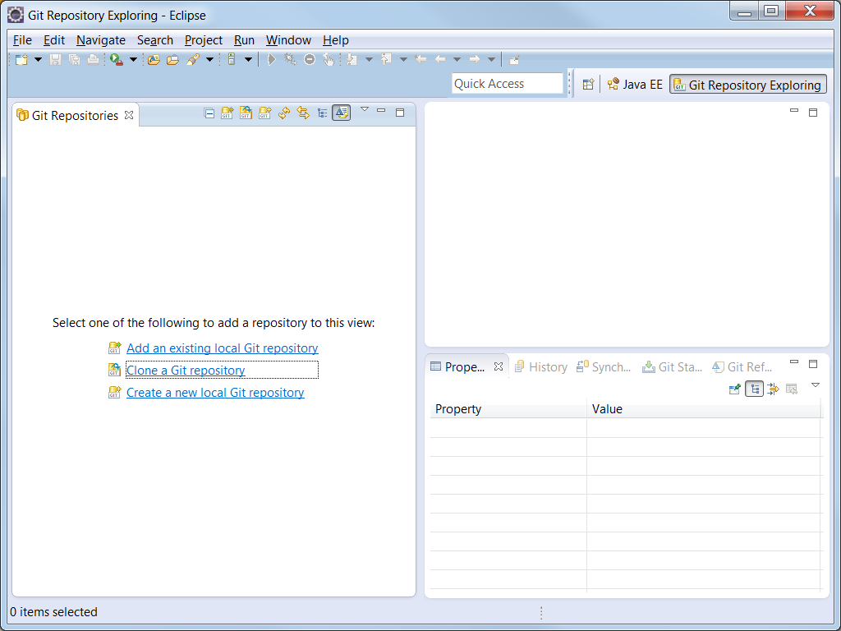

  - Clone the remote repository
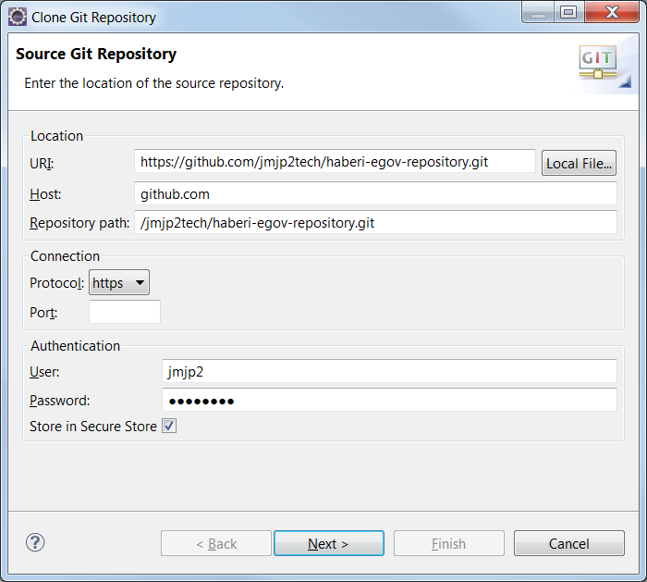

URI: https://github.com/jmjp2tech/haberi-egov-repository.git
User / password nabiguhaye muri email ivuga kuri GIT.

  - Take only the last branch : stable-010

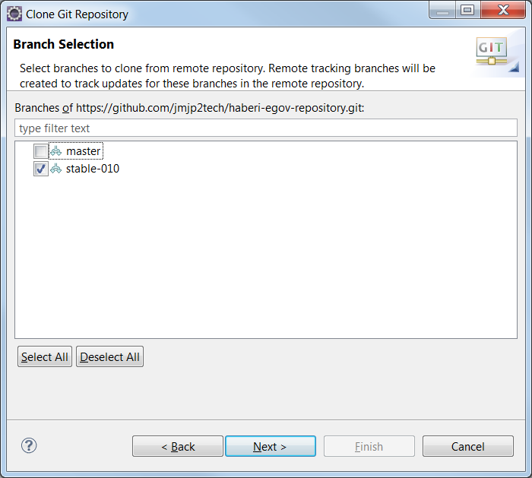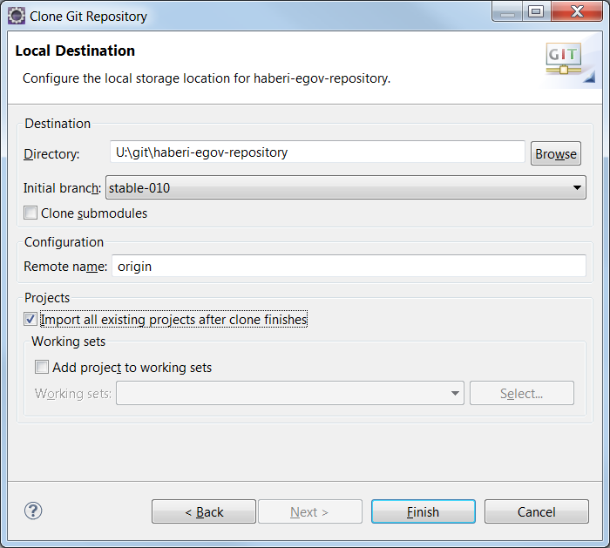

After that, you should have a new repository in your perspective:

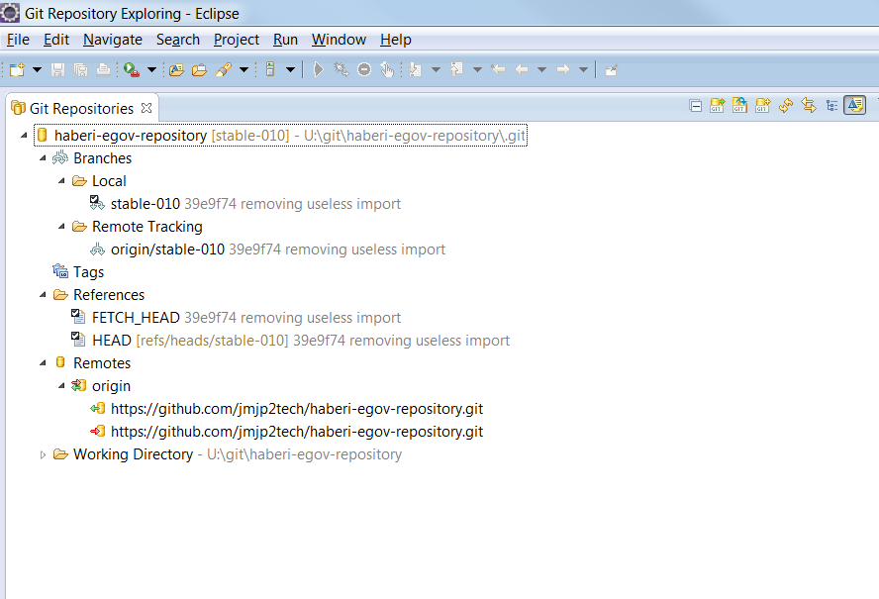

  - Correcting jar dependencies errors.
[After checking out the code , it is possible that the Jdk, glassfish4 and ,may be , other dependencies be not welll referenced anymore. You will have to fix all java-related error (leave the javascript errors , as they do not affect the build & deployment process anyway)].

Change the perspective to JavaEE perspective.

- Add the glassfish server .
In the JavaEE , go to “Servers” view , and click on the link “No servers are available. Click this link to create a new server ”.

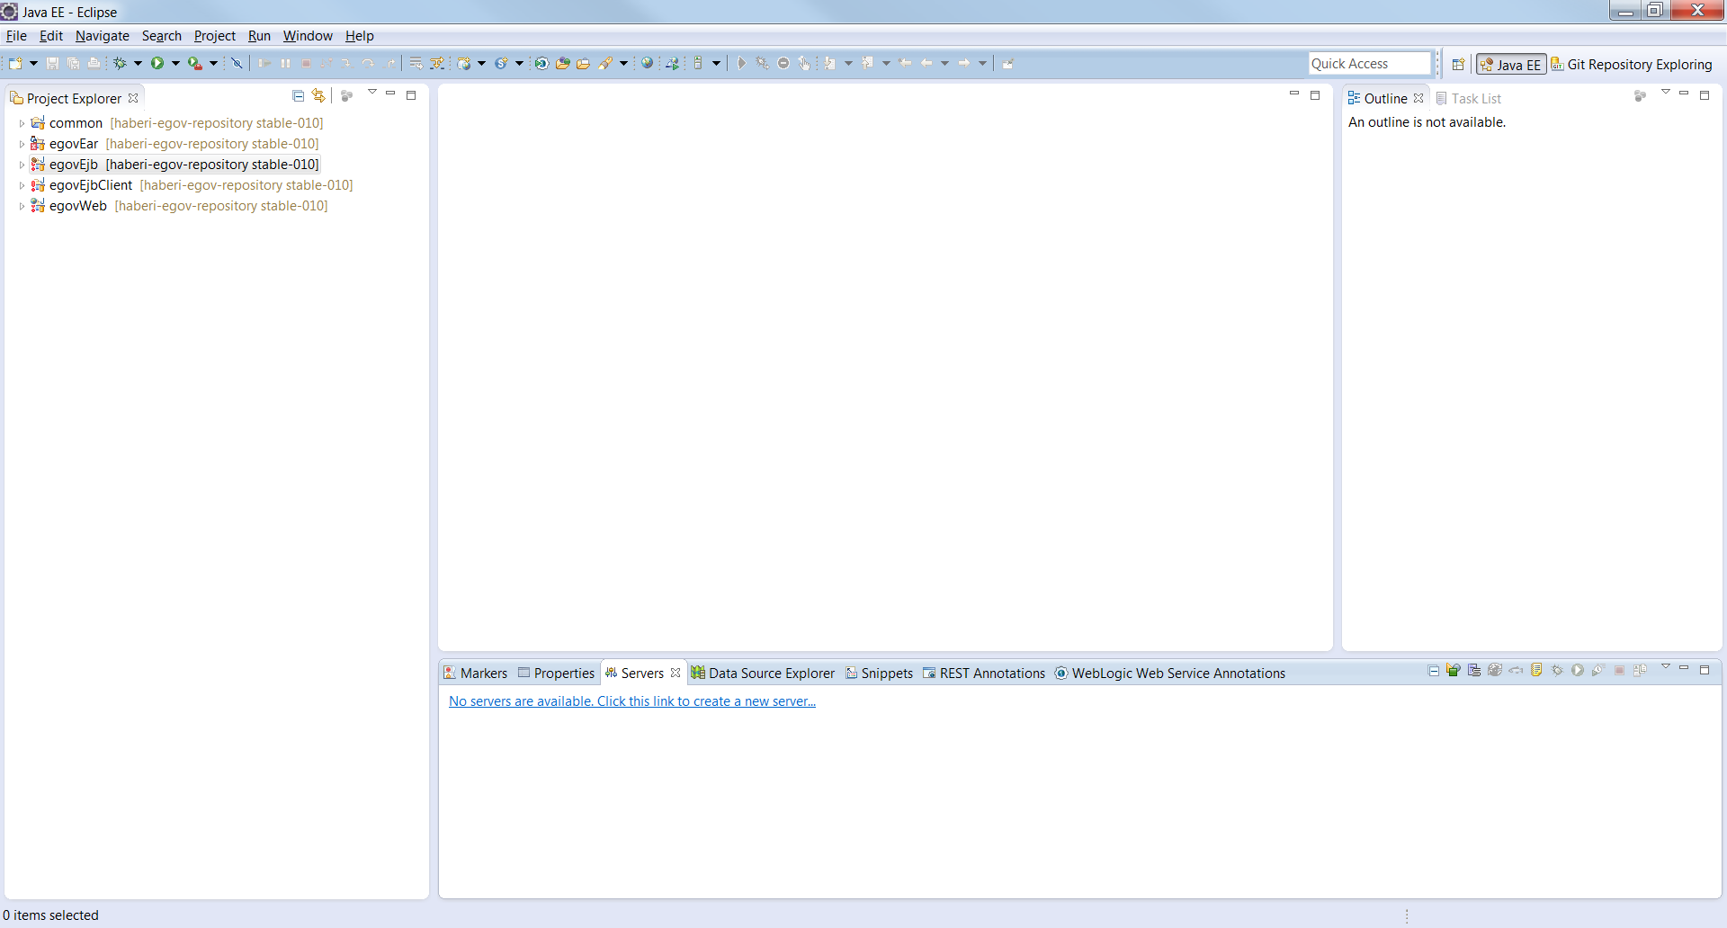

- In the list of servers , look for Glassfish 4.0 . Then tell eclipse where Glassfish 4 is installed (i.e its root folder\glassfish. In this case , it should be C:/dev/tools/glassfish4/glassfish).

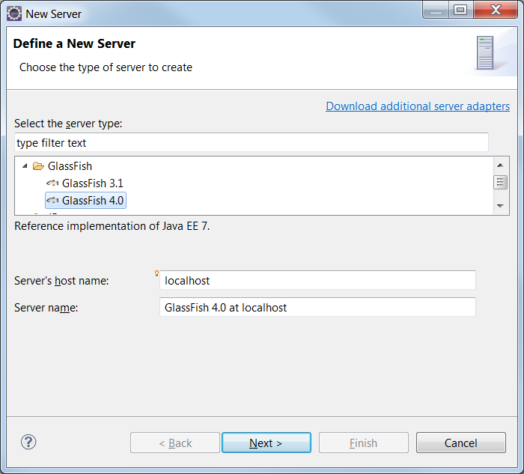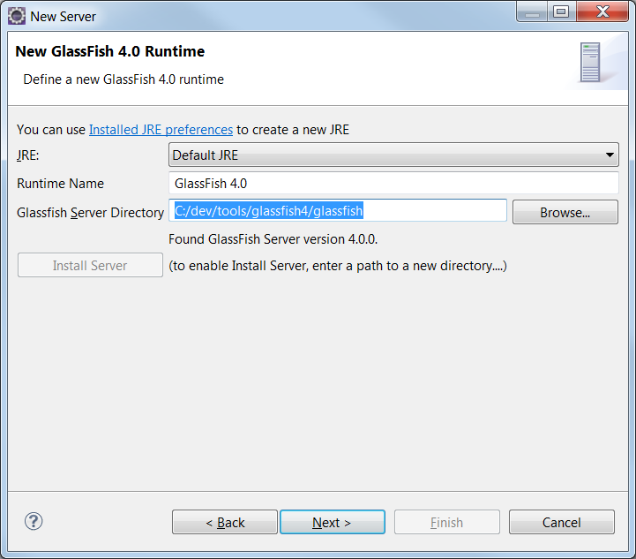
On the next screen, leave the default input , just click “Finish”.

- Check that the “Glassfish4” libraries are available to your projects in Eclipse.
Always in JavaEE perspective , go to “egovEjb” project , and expand “Glassfish System Libraries”. It should show many Jar libraries (a bit like the next screenshot).
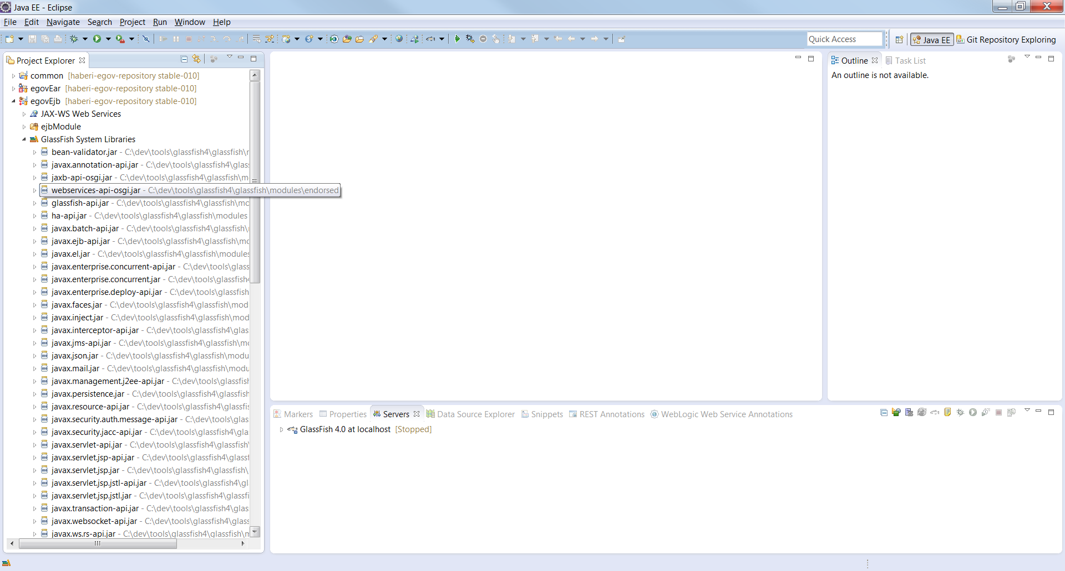

- Adjusting the JRE System Library.

Right –click on the project “egovEjb” ➔ Build Path ➔ configure build path …

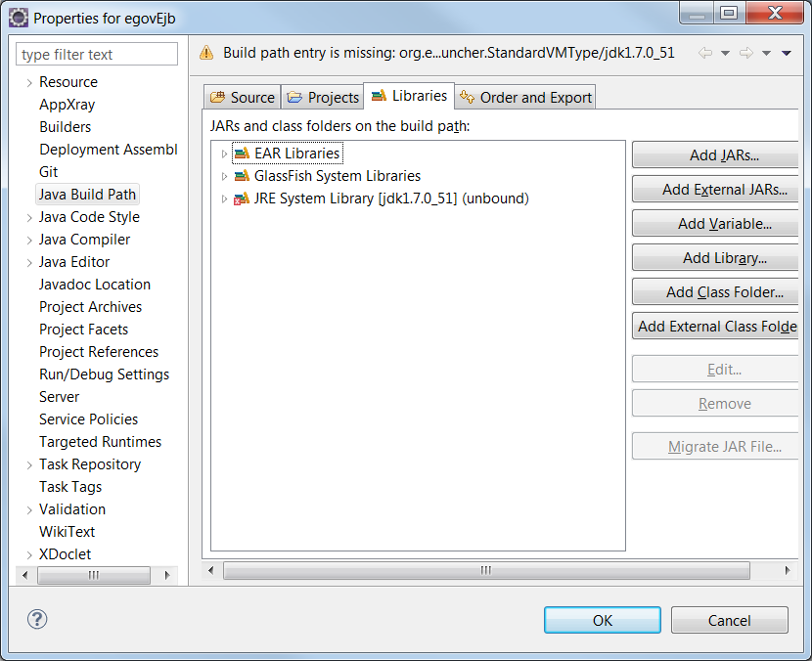

Parenthese : If you have a cross on JRE System Library , it is because the JRE declared by the project (on GITHub) is not found by Eclipse. Hence , we need to adjust , to point to the real JRE path in your system.

Click on “JRE System Library”, then on the button “Edit….”. Then choose the Workspace default JRE (in my case , it is jdk1.7.0_55), then click “Finish”.
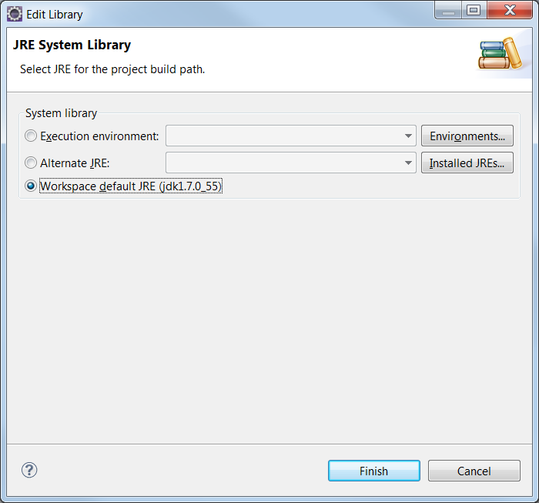

Parenthese: This should solve the JRE issue . However there will still be errors on the project egovEjb. For now, ignore them . They are caused by another project (egovEjbClient).

- Repeat the process on egovEjbClient and egovWeb projects , to resolve their JRE issues .

- In the menu Project➔ clean (choose “clean all projects” , if not already chosen). Then click OK

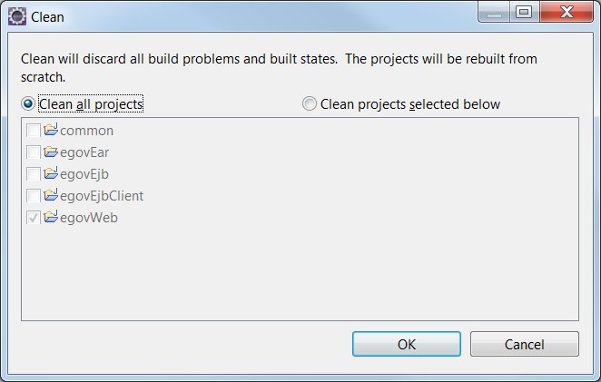

This should finish all java-related errors. You now have a clean workspace .
Database installation

- You can download the installer on http://dev.mysql.com/downloads/installer/5.6.html
- Install MySql into C:/dev/tools , like other dev tools.
- Configure the MySQL (add a user with full privileges , or just use the root user + give it a service that auto-start on computer start-up).
  - Username = “root” , password= “password”
- Create a database named “egov”
  - Make sure to set the default character set to latin1 (on the command line:
CREATE DATABASE `egov` DEFAULT CHARACTER SET latin1 )

Deploy the code on the server in Eclipse

- Got to “servers” perspective and start “glassfish 4.0 at localhost”
- Right-click on the server ➔ add and remove … ➔ choose “egovEar” and click on “add” button . Finally click on “finish” button.

This conclude the deployment of the EAR file on the server.

Testing the installation:
- Test the database tables creation
Log into “mysql command line”. Execute the following commands :
- use egov ;
- show tables ;
The result should show that 4 tables have been created (egov_users , egov_accounts ,egov_addresses, egov_identity_papers).

FYI: These table were dynamically generated by JPA (Jave persistance API)
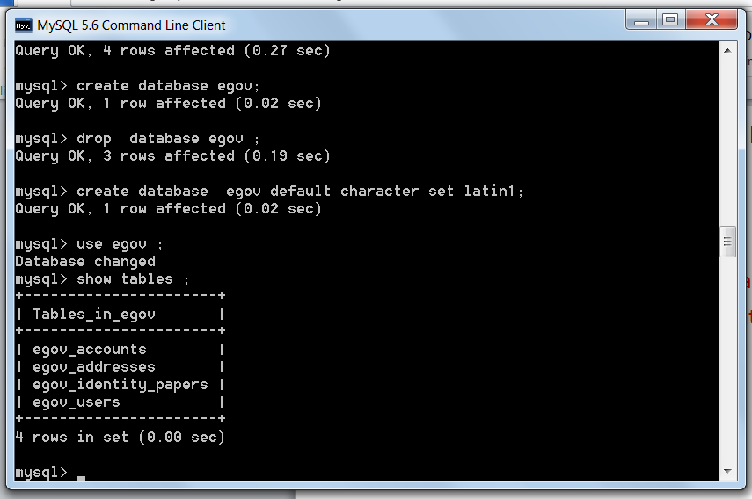

- Test the jsp files
Open a browser and go to http://localhost:8080/egovWeb/jsp/user_register.jsp

Result :
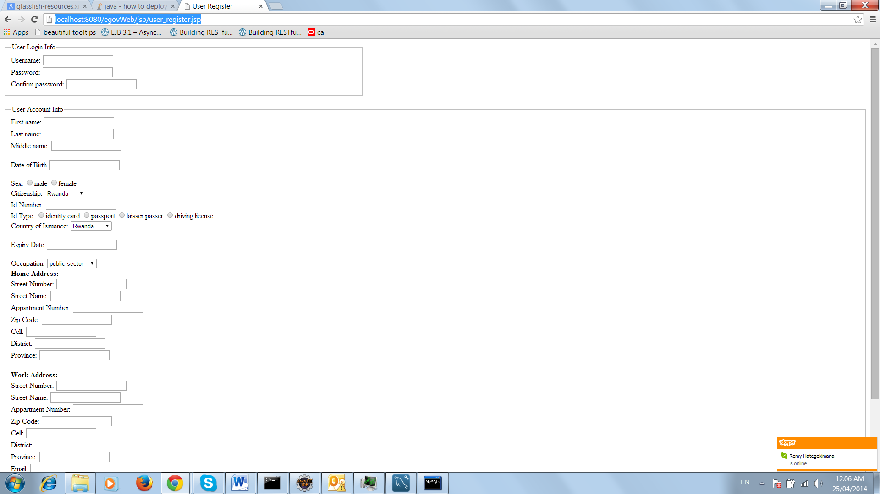

- Test the insertion of a new user
fill in the form on the jsp and click on “Create Account” button,

Result:
the first user + account + address + id will be inserted in the egov database.

